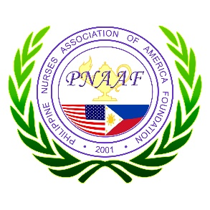
The Philippine Nurses Association
of America Foundation
1346 How Lane, Suites 109-110, North Brunswick, NJ, 08902

Certificate of Completion

has attended and successfully completed the

Lead to INSPIRE Virtual Spring Conference 2026:
Advancing Nursing Excellence Through Research, Evidence, and Innovation

April 18, 2026

Peter-Reuben Calixto
PNAAF Accredited Provider Program Director

The Philippine Nurses Association of America Foundation is approved by the California Board of Registered Nursing, Provider 14143, for 4.5 contact hours

